Setting up your Iphone App
- First of all, download the App and open it.
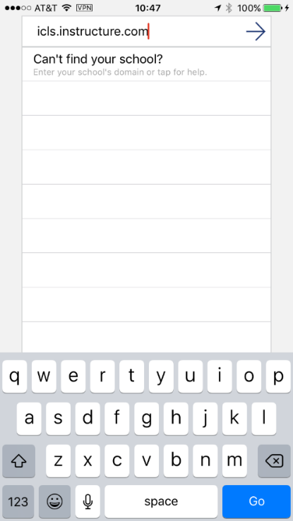
- In the’search’ box, enter icls.instructure.com and click on ‘Go’ or the arrow…

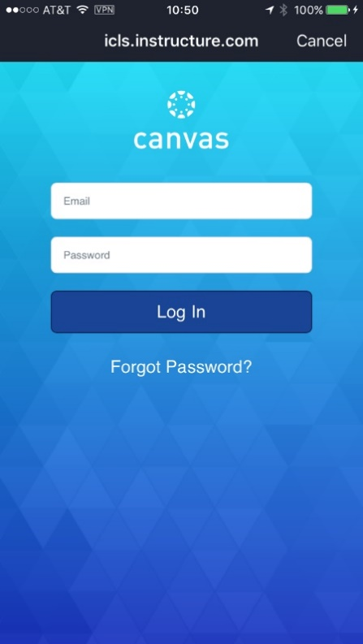
- You should then arrive at the page below, where you can enter your email address and PW.

